Machine Learning Algorithms

Types of Machine Learning

- Supervised Machine Learning
- Unsupervised Learning

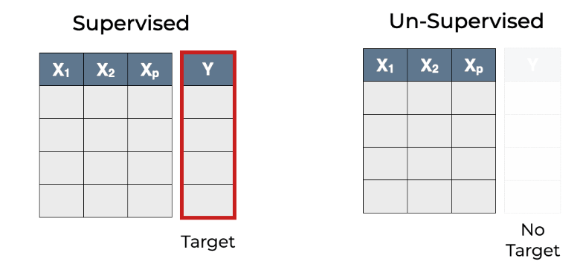

- Supervised Machine Learning : It is a type of Machine learning where the model is trained over labeled data means the output of the training set is already known.
Like x is independent input variable has y output.
The model in trained on such x,y input and output variable to predict as accurate y in following test set.
Here weight = X and Height= Y

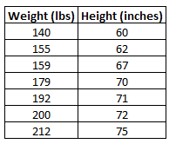
Supervised ML can have multiple factors x independent variables x1,x2…. etc,..

EXAMPLE:
The house price : Predict the price of house on following features like
(Area, sqr. feet, no. of rooms,nearest market or city, etc,..) (Regression)
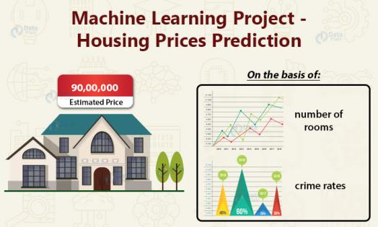

Cat or Dog : Guess is it cat or dog using the label dataset to train on labeled data. (Classification)

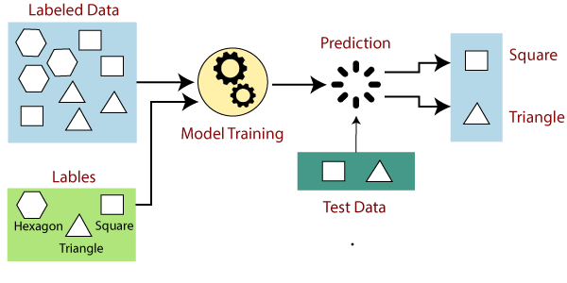

- Unsupervised Learning : As the name suggest unsupervised means not under supervision means we lack target value or label y in the following data.
Unsupervised learning is basically finding the meaning from the data means identifying the pattern, grouping them together, extracting the features out of them.

EXAMPLE : An interesting use case thought while making this document
- E-commerece Store : Lets assume you have a E commerce store where there are 3
Sections:
- Men
- Women
- Kids (0-7 years)

Now the company is experiencing more number of number of return than the past month. Now a ML Engineer/Data Analyst is assigned the task find out why we are experiencing certain downfall of these customers.
(Note Analysis of data meant finding the pattern in the data and grouping and identifying the cause of problem.)

REPORT :
So after clustering the data we found out that the 40% of returned package have issue of size which are either ordered Men S size or Kids section largest size .

From this we were able to know the order might be for customer age 9-16 which the e-commerce store is lacking to provide, hence there is a need for an update in the following App for customer targeting Adolescents and providing correct sizes for them.

It was an example of clustering in an unsupervised algorithm technique used generally for target marketing.

Supervised Machine Learning Algorithms

This is divided into two supervised learning algorithm

- Regression
- Classification
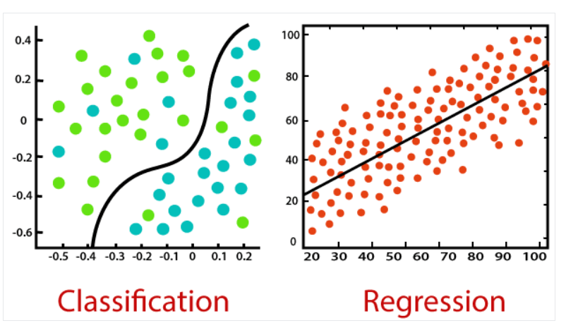

- REGRESSION :
Regression is a type of supervised machine learning where algorithms learn from the data to predict continuous values such as sales, salary, weight, or temperature.

There are many machine learning algorithms that can be used for regression tasks. Some of them are:
- Linear Regression
- Decision Tree Regressor
- K Nearest Neighbor Regressor
- Random Forest Regressor
- Neural Networks

- CLASSIFICATION :
Classification is a type of supervised machine learning where algorithms learn from the data to predict an outcome or event in the future.

Classification algorithms are used to predict different outcomes with 2
possibilities true/false ,yes/no etc,. are known as Binary classification.
When the outcome contains more then 2 possible values it is multiclass
Classification. Some Machine Learning algorithms are:-

- Logistic Regression
- Decision Tree
- K Nearest Neighbour
- Random Forest classifier
- Neural Networks

